GPAT 2019
Ten students of Govt. College of Pharmacy, Rohru have qualified the GPAT 2019 examination conducted by National testing agency.
 |  | 
Sangeeta Sharma  AIR-183 |  | Pulkit Rajan  AIR-1116
 |  | 
Banwari Lal  AIR-2867 |  | Alka Kumari  AIR-3003
 |  |  | 
 | Ishita Atwal  AIR-4367 |  | Ankaj Kumar  AIR-4652
 | 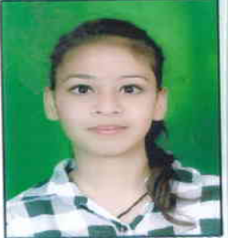 |  | 
 | Lakshita Dogra  AIR-4652 |  | Chhveen Bharti  AIR-5697
 | 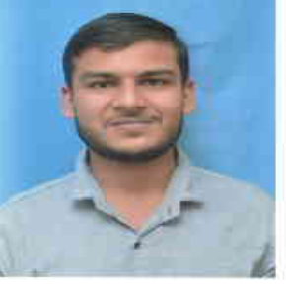 |  | 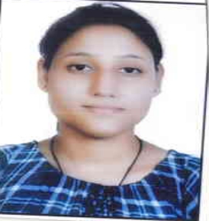
 | Kartik  AIR-6137 |  | Shallu Sharma  AIR-6710

